**Task 11-CHatGpt**

**Using Tables and <div> Elements for Layout in CSS**

**Tables** and **<div> elements** serve different purposes in web design. Understanding their appropriate usage is essential for effective layout design.

**Tables**

* **Purpose**: Primarily used for displaying tabular data (rows and columns).
* **Structure**: Elements include <table>, <tr>, <td>, etc.
* **Styling**: Tables can be styled with CSS, but they may not be as flexible for responsive design.

**<div> Elements**

* **Purpose**: Used as a generic container for content and is often styled with CSS to create complex layouts.
* **Structure**: Can contain any HTML elements and be nested.
* **Flexibility**: Highly flexible, making it suitable for responsive designs and various layout strategies (e.g., flexbox and grid).

**Example HTML Document**

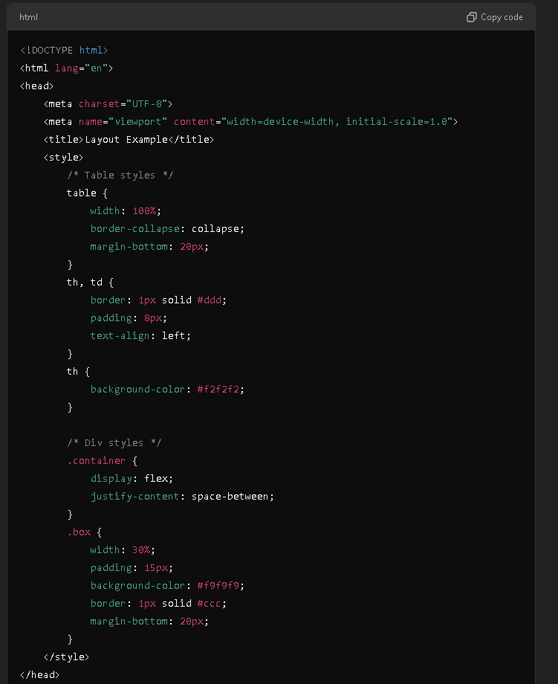

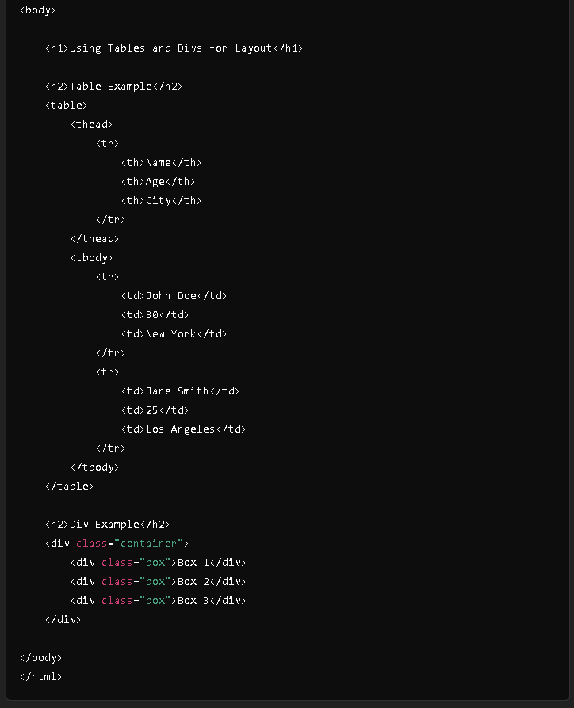

**Result**

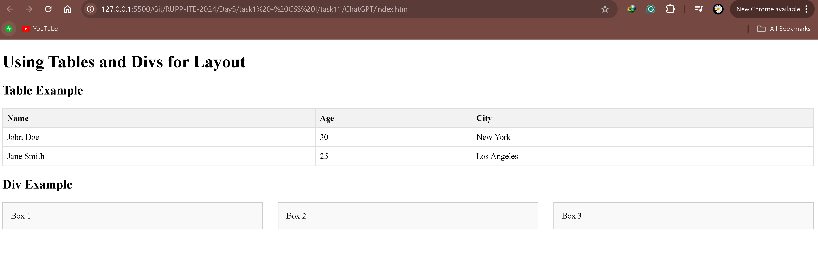

**Discussion: When to Use Tables vs. <div> Elements**

* **Use Tables**:
  + When displaying structured data (e.g., financial reports, schedules).
  + When you need a clear row-and-column layout.
* **Use <div> Elements**:
  + For layout and design purposes, especially for responsive designs.
  + When you need more control over positioning and styling.
  + For complex layouts that require CSS frameworks or techniques (e.g., flexbox, grid).

**Conclusion**

While both tables and <div> elements can be styled with CSS, their appropriate use depends on the type of content being presented. Tables should be reserved for tabular data, while <div> elements are better suited for layout purposes.